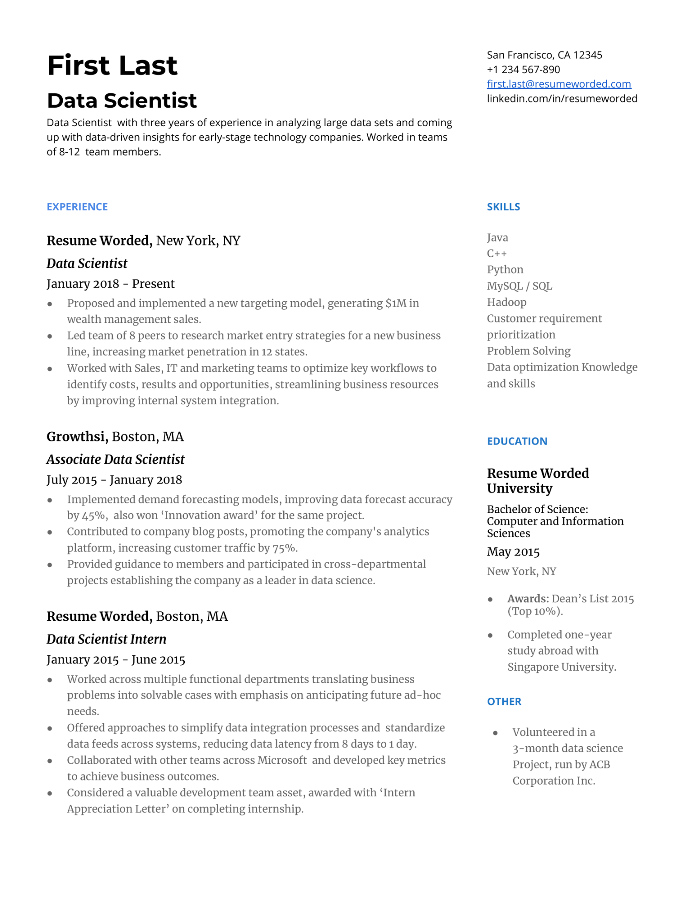
First Last
Data Scientist
Data Scientist with three years of experience in analyzing large data sets and coming up with data-driven insights for early-stage technology companies. Worked in teams of 8-12 team members.
San Francisco, CA 12345
+1 234 567-890
first.last@resumeworded.com
linkedin.com/in/resumeworded
EXPERIENCE
Resume Worded, New York, NY
Data Scientist
January 2018 - Present
•
•
Proposed and implemented a new targeting model, generating $1M in wealth management sales.
Led team of 8 peers to research market entry strategies for a new business line, increasing market penetration in 12 states.
Worked with Sales, IT and marketing teams to optimize key workflows to identify costs, results and opportunities, streamlining business resources by improving internal system integration.
Growthsi, Boston, MA
SKILLS
Java
C++
Python MySQL/SQL Hadoop
Customer requirement prioritization
Problem Solving
Data optimization Knowledge and skills
Associate Data Scientist
July 2015 - January 2018
Implemented demand forecasting models, improving data forecast accuracy by 45%, also won 'Innovation award' for the same project. Contributed to company blog posts, promoting the company's analytics platform, increasing customer traffic by 75%.
Provided guidance to members and participated in cross-departmental projects establishing the company as a leader in data science.
Resume Worded, Boston, MA
Data Scientist Intern
January 2015 - June 2015
Worked across multiple functional departments translating business problems into solvable cases with emphasis on anticipating future ad-hoc needs.
Offered approaches to simplify data integration processes and standardize data feeds across systems, reducing data latency from 8 days to 1 day. Collaborated with other teams across Microsoft and developed key metrics to achieve business outcomes.
Considered a valuable development team asset, awarded with 'Intern Appreciation Letter' on completing internship.
EDUCATION
Resume Worded University
Bachelor of Science: Computer and Information Sciences
May 2015
New York, NY
•
Awards: Dean's List 2015 (Top 10%).
•
Completed one-year
study abroad with
Singapore University.
OTHER
Volunteered in a 3-month data science
Project, run by ACB Corporation Inc.

